

Dr. Latoya, Powell inc.
2018-08-06
Dr. Powell
7415 Carter Ridges Suite 291, Maryfurt, ME 33937
Phone: 8738670273
Fax: 6658814226

Re: Suzanne, Dawson
PHN: 8413287967
Birthdate: 18-Oct-1941
Address: 0342 Ashley Passage Suite 031, West Reginaldland, MS 05711
Patient number: 556140543

To Whom It May Concern:

This is a medical letter to state the above patient is pregnant with expected delivery date of 08-Feb-2025. Hoping this information is satisfactory for your requirements.

Thank you.

Sincerely,
Dr. Latoya, Powell
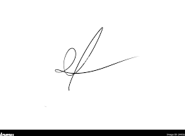
FRCS© NCMP
Clinical Assistant Professor, UBC
Department of Obstetrics and Gynecology SMH

